Defects Database Upgrade

Originator: John Dillon

Purpose:
Extend functionality of existed excel workbook “Defect Database.xls”. Provide interactive panel for inserting data with choosing lists and verification.

Expected benefits:
Save time necessary for fulfilling the form. Improve quality.

Required functionality:
Functionality | Designed
Defect Type column validation corresponds to value in Defect Location column | Ok
Workstep column validation corresponds to value in Type of Product column | Ok
Administration panel for Defect Type->Defect Location & Type of Product->Workstep | Ok
Visual DialogA – panel for inserting data (VDB – inactive) | Ok
Visual DialogB – panel for inserting lot history data (VDA – inactive) | Ok
Visual Dialog - Printing functionality | Ok
Checking file integrity, validation of the administration panel | Ok
Two modes of filling form – manual + visual | Ok

Implementation:
New Defect Database was implemented as version 2 subversion 0 – refer to cvslog for details:
- preparing basic lists in administration panel | Ok
- implementing administrative functionality  - collecting sub-lists corresponding to both main list – for DefLocation and TypeofProduct | Ok
- creating references (RangeNames => lists) | Ok
- checking for double entries (keys) | Ok
- cleaning functionality | Ok
- password protection functionality | Ok
- auto-saving at leaving worksheet functionality | Ok
- enabling two modes: manual, visual | Ok
- implementing manual mode | Ok
- creating visual dialogs | Ok
- implementing entering data following process flow diagram  - OpenDefectDatabase => SelectLine => Enter LHR Data => Enter Defect Data => Close LHR (- autosave, - optional printing) => Enter LHR Data^ or Close LHR => Close Line => Select Line^ or Quit | Ok
- implementing Visual forms | Ok
- inserting data into base | Ok
- printing functionality (remember entries) | Ok
- scrolling functionality (replaced by modalmode = false) | Ok
- checking file integrity at start | Ok
- testing - > unstable release -> bugfixing, additional functionality (betha) | Ok
- release candidate -> bugfixing (cr) | Ok
- release: Defect Database.2.0.final.xls, | Ok
- Defect Database.2.0.final. - review panel.xls (added after releasing) | Ok
Progress (19 steps): | 100%
User Guide for version 2.0:
General information
The Macro starts automatically, during opening worksheet and Enter window appears to allow user to choose his competition and work mode.
    - Enter Defects – starts main window for entering data
    - Administration – allow make changes in program options – restricted area
    - Review – close visual mode and allow enter data on manual way
    - Help – shows this informations
Program can be started by running macro – “ThisWorkbook.DefectDatabaseVisual”.
Macro provide menu-bar “DDatabase” with functions: Enter Defects, Administration, Close All. Action taken is as described above.

Entering Defects (visual) – main window for entering data. Imputers work area.
Program works in 3 steps, title of active field of interest is green:
- Entering current line – then pressing Accept button is required for activate LHR section
- Entering information from LH Record – all fields must to be properly filled. User can come back to choosing line section by pressing “Close Line” or activate next section by pressing “Accept” button. The last action activates next section.
- Entering information about Defects – all fields must to be properly filled. After filling all fields used can insert data into worksheet by pressing “Next Defect” button or leave this section and come back to LH Data by pressing “Exit From Defect” button. The Last Action does not insert information from fields into worksheets.
Program provide printing function by pressing “Print” button. Action will print data entered since last Line number was changed. Function sets print area in the worksheet so user can print data for last entered (closed) line as long as he/she will try to print new data.
2 more actions – “save”, “exit” are available with actions as usual.
User can use menu to activate this window after closing it.

Administration – administrative panel for changing program options. Engineers work area.
Access to Administration panel can be obtained after pressing “Administration” button or choosing Administration on menu-bar and it is granted after providing correct password
Administrator should not change any fields marked on orange color as this changes require coding work to keep macro working. Yellow color contains main category lists where administrator can add or delete categories.
Adding new category
There are two list contains main category:
  - Defect Location
  - Type of Product
To add category click inside the desired list and type new category;
Adding items for new category
- Creating list for category
To add item for category the new list with header and desired items must to be created anywhere on worksheet. Header of this list must to be exactly the same than existed category (copy – pasting method is strongly recommended). Refer to MS Excel Help for information how to create the list.
For link category with its items click “UpdateList” button.
- Deleting category
Delete entry from main category list, resize list to correct size (no empty entries); delete items list
Click “ClearReferences” button and then “UpdateList” button
Changing items for existed categories
To add item click cell just below the target list and type new item. Use list functionality for sorting
To delete item click desired cell and delete. Use list functions for sorting. Change size of the list by drag its border.
To change item click desired cell and change it.
After any modification administrator should click “ClearReference” and “Update List” to save and update changes.
“Validate” button can be used for checking program integrity.
Password TextBox is provided for saving and changing password. To change it, just type new one

Troubleshooting
Error codes and recommended action are below.
01 – Doubled entry in Defect Location
Defect Location list must contain unique values. Change entries.
02 – Doubled entry in Type of Product
Type of Product list must contain unique values. Change entries
03 – Administration sheet does not exist or have changed name
Worksheet for administration panel must be named “Administration”. Change its name to correct one
04 – Wrong name for Rejects form given in “Administration”->”MainFormName” textbox
Check reference provided on Administration panel with the name of data storing worksheet
05 – Rejects sheet does not exist or have changed name
Restore data storing worksheet or change its name for correct.
06 – References table broken
Refresh data by clicking “Clear References”, “Update Lists”. If it is still broken, call for Visual Basic programminst.
07 – Setting password failed - deprecated
08 – Wrong password - deprecated

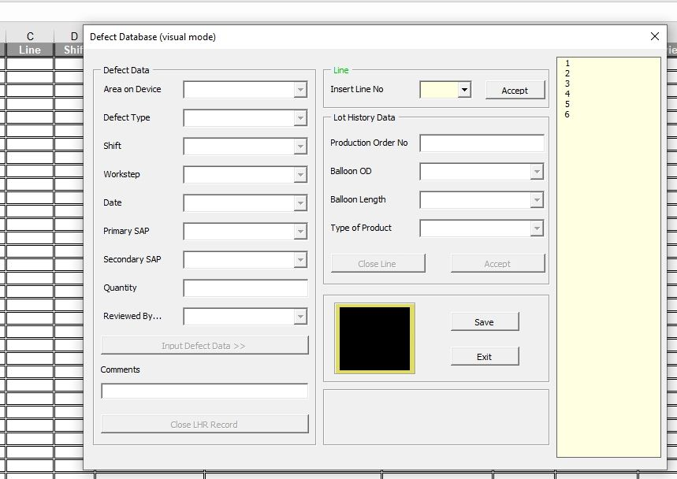

Version Track:
Defects Database – 2.0:
1 May 2008 – release.
I am not able validate the program. Hope everything will be fine.
2 May 2008 – validation.
The update on tasks is included at the bottom.
Issues so far;
1) Defect Database FY08 is this in place and visible on some computers
(No issue with Line Floaters)
2) Problems with roll out of the Review files.
(Daniel resolved this morning)
3) Problem with old Computer beside Point of Use (near Testometric). It seems to be too old to run the Defect Database. This was only flagged on evenings. Not sure of days.
(Computer does not support visual basis, flagged to Line Floaters to use another)
4) Shortcuts on computers need to be updated to the new file. I will flag with an email tomorrow.
(Outstanding action, John)
5) Need to review with Daniel going back on partially entered data to change it. What is correct method. One problem with that today.
(Review complete, editing of actual worksheet is best option i.e. close the Defect Entry form and edit worksheet.)

Initial feedback from Floaters/QA Eng continues to be good, and from Engineers better with roll out of Reviewer files. Some data entered into FY08 yesterday, none today.
6 June 2008 – review due to error “Compile error in hidden module: this workbook”.
Probably, the problem appeared due to certification trouble. The database was not able to receive the certification key for electronic signature (or maybe the certification subsystem is switched off) and verify the publisher. Following it application did not allow to run any macro code.
The new version of the database was build from blank file and exported previously macro code. The electronic signature was not attached this time. All data were copied from old file into the new one.
The database start working correctly on all tested computer, especially on the ones it did not work before.
As some additional functions were added this action is marked as upgrade and version number was increased to 2.1.
The SDS Defect Database was issued for testing just before. It was forecasted that SDS Defect Database would generate the same issue. New base from version 2.1 file has been created.

Defects Database – 2.1: (\Manufacturing Bld2\Defect Database)
6 June 2008 – release. This version replaces the previous one (Defects Database – 2.0).
Feature added:
Initialize database – allow rebuilding database code from raw basic code.

SDS Defect Database – 2.1: (\Manufacturing Bld2\SDS Defect Database)
4 July 2008 – new instance of Defect Database – 2.1 released.
25 September 2008
For organizational and code maintenance purpose I changed name for database working on POBA Dep (personal cvs only).

Peripheral Defects Database – 2.1: (\Manufacturing Bld2\Defect Pivot tables FY09\Line 1P)
15 October 2008 – new instance of Defect Database – 2.1 released.
During the implementation new bug was unhidden. Application does not accept non alphanumerical signs as name for Named Ranges. Named Range is used for referencing purpose in the code. Additional substitutes were added to the function “SetReferences”.
The patch was applied to the Defect Databases in local cvs repository.

21 November 2008
The title of column A was changed to “Area On Device”. Macro code was changed to suit with untypical title of column E – “Product”.

Balloon Room Defects Database - v2.1: (\Manufacturing Bld2\Balloon Room\Reject Review)
21 November 2008 – new instance of Defect Database – 2.1 released
(changes in code, additional layout/interface changes required)

Endovascular Defect Database – v2.1: (\Manufacturing Bld2\Endovascular - B3)
21 December 2008 – new instance of Defect Database – 2.1 released
(small code changes)

Endovascular Defect Database – v2.2: (\Manufacturing Bld2\Endovascular - B3)
10 January 2009 – upgrade to version 2.2.
- Change Batch # to read PO #.
- Add a column "Critical Defect" with yes and no in the drop down menu.

Balloon Room Defects Database - v2.2: (\Manufacturing Bld2\Balloon Room\Reject Review)
24 January 2009 – upgrade to version 2.2
- Profiles functionality added – BalloonDD-2.2.doc

Endovascular Defect Database – v2.2: (\Manufacturing Bld2\Endovascular - B3)
27 January 2009 – upgrade to version 2.3.
- Column "Handle Batch #" added

Considering new version branch of database.
Integrated collecting defect data system for all departments with VCS + SQL.

